|  |  |  |  |
| --- | --- | --- | --- |
| 2 | | 40,032 | |
| **NUMERO DE FRONTERAS** | | **ENERGIA AGREGADA** | |
|  | | | |
| 150,072,622 | 163 | | 6,882,688 |
| INGRESO 2021 | DÍAS CERTIFICADOS 2021 | | ENERGIA RESPALDADA 2021 |

**HISTORICO REINTEGRO DDV**

|  |  |
| --- | --- |
|  | **2021** |
| **ENE** | 18.89 |
| **FEB** | 24.6 |
| **MAR** | 11.47 |
| **ABR** | 1.49 |
| **MAY** | 20.75 |
| **JUN** | 6.56 |
| **JUL** | 17.46 |
| **AGO** | 16.34 |
| **SEP** | 16.68 |
| **OCT** | 15.83 |
| **NOV** | - |
| **DIC** | - |

**Los valores de la tabla están en millones de COP**

**REINTEGRO MECANISMO DDV OCTUBRE 2021**

|  |  |  |  |  |  |
| --- | --- | --- | --- | --- | --- |
| FECHA | TIPO DIA | CANTIDADES RESPALDO | PRECIO PONDERADO USD | TRM | PNETO |
| 2021-10-06 | Miércoles | 40,030 | 5.98 | 3,784.44 | 811,702 |
| 2021-10-07 | Jueves | 40,028 | 5.98 | 3,784.44 | 811,662 |
| 2021-10-08 | Viernes | 40,028 | 5.98 | 3,784.44 | 811,662 |
| 2021-10-09 | Sábado | 40,028 | 5.98 | 3,784.44 | 811,662 |
| 2021-10-10 | Domingo - Festivo | 40,030 | 5.98 | 3,784.44 | 811,702 |
| 2021-10-11 | Lunes | 40,028 | 5.98 | 3,784.44 | 811,662 |
| 2021-10-18 | Domingo - Festivo | 40,030 | 5.98 | 3,784.44 | 811,702 |
| 2021-10-19 | Martes | 40,030 | 5.98 | 3,784.44 | 811,702 |
| 2021-10-20 | Miércoles | 40,030 | 5.98 | 3,784.44 | 811,702 |
| 2021-10-21 | Jueves | 40,030 | 5.98 | 3,784.44 | 811,702 |
| 2021-10-22 | Viernes | 40,028 | 5.98 | 3,784.44 | 811,662 |
| 2021-10-23 | Sábado | 40,028 | 5.98 | 3,784.44 | 811,662 |
| 2021-10-24 | Domingo - Festivo | 40,028 | 5.98 | 3,784.44 | 811,662 |
| 2021-10-25 | Lunes | 40,028 | 5.98 | 3,784.44 | 811,662 |
| 2021-10-26 | Martes | 40,028 | 5.98 | 3,784.44 | 811,662 |
| 2021-10-27 | Miércoles | 40,030 | 5.98 | 3,784.44 | 811,702 |
| 2021-10-28 | Jueves | 40,030 | 5.98 | 3,784.44 | 811,702 |
| 2021-10-29 | Viernes | 40,029 | 5.98 | 3,784.44 | 811,682 |
| 2021-10-30 | Sábado | 40,029 | 5.98 | 3,784.44 | 811,682 |
| 2021-10-31 | Domingo - Festivo | 20,014 | 5.98 | 3,784.44 | 405,831 |

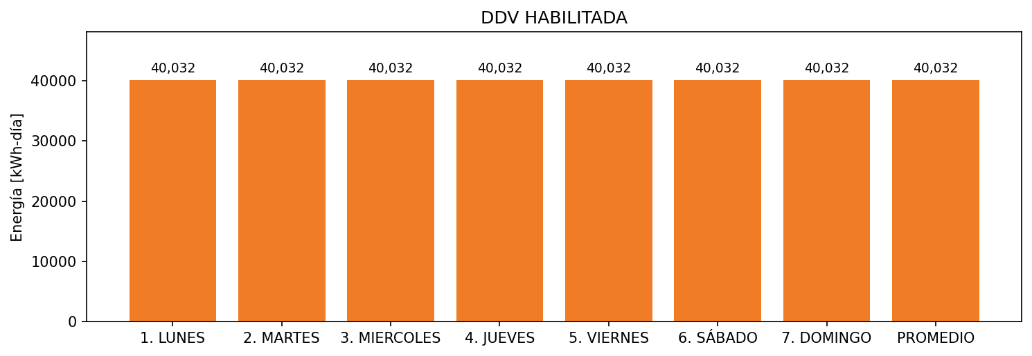

|  |  |  |  |  |  |  |  |  |  |
| --- | --- | --- | --- | --- | --- | --- | --- | --- | --- |
| **FRONTERA** | **COD SIC** | **FRT DDV** | **TIPO DDV** | **PROMEDIO** | **PRÓXIMA ACTUALIZACIÓN** | **MARGEN DE ERROR** | **ÚLTIMA PRUEBA DDV** | **DÍAS PARTICIPACIÓN** | **FECHA REFERENCIA PRÓXIMA PRUEBA DDV** |
| SOCIEDAD PORTUARIA REGIONAL DE BUENAVENTURA S.A. | Frt00597 | Frt39459 | GPE | 20,016 | 2026-04-15 | NO APLICA | 2021-06-30 | 95.0 | 2021-12-18 |
| SOCIEDAD PORTUARIA REGIONAL DE BUENAVENTURA S.A. | Frt24402 | Frt39793 | GPE | 20,016 | 2026-04-15 | NO APLICA | 2021-06-30 | 54.0 | 2021-12-18 |